**Practical 9: MongoDB $abs, $floor, $ceil Operator**

1. Database: userdb
2. Collection: student
3. Document: Six documents that contain the details of the students

{

{

"_id" : ObjectId("56254d4fdf2222265r4g12ds3d65f"),

"std_name" : "Micky",

"gender" : "Female",

"class" : "X",

"fees" : 5000,

"exam_fees" : 500,

"age" : 16,

"Total_marks" : 405

"Result" : "Pass"

},

{

"_id" : ObjectId("56254d4fdf2222265r4g12ds34563"),

"std_name" : "Moty",

"gender" : "Male",

"fees" : 4000,

"exam_fees" : 500,

"class" : "VII",

"age" : 15,

"Total_marks" : 705

"Result" : "Pass"

},

{

"_id" : ObjectId("56254d4fdf2222265r4g12ds31478"),

"std_name" : "Thomas",

"gender" : "Male",

"fees" : 3000,

"exam_fees" : 500,

"class" : "V",

"age" : 12,

" Total_marks" : 450

" Result" : "pass"

},

{

"_id" : ObjectId("56254d4fdf2222265r4g12ds37832"),

"std_name" : "Jin",

"gender" : "Female",

"fees" : 5000,

"exam_fees" : 500,

"class" : "X",

"age" : 16,

"Total_marks" : 750

"Result" : "Pass"

},

{

"_id" : ObjectId("56254d4fdf2222265r4g12ds1c46"),

"std_name" : "Mia",

"gender" : "Female",

"fees" : 6000,

"exam_fees" : 500,

"class" : "XI",

"age" : 17,

" Total_marks" : 450

"Result" : "Pass"

},

{

"_id" : ObjectId("56254d4fdf2222265r4g12ds315hj"),

"std_name" : "Mike,

"gender" : "Male",

"fees" : {

"school_fees" :4000,

"exam_fees" : 500,

"pending_fees" : 950,

}

"class" : "V",

"age" : 15,

"Total_marks" : 450

"Result" : "Pass"

}

}

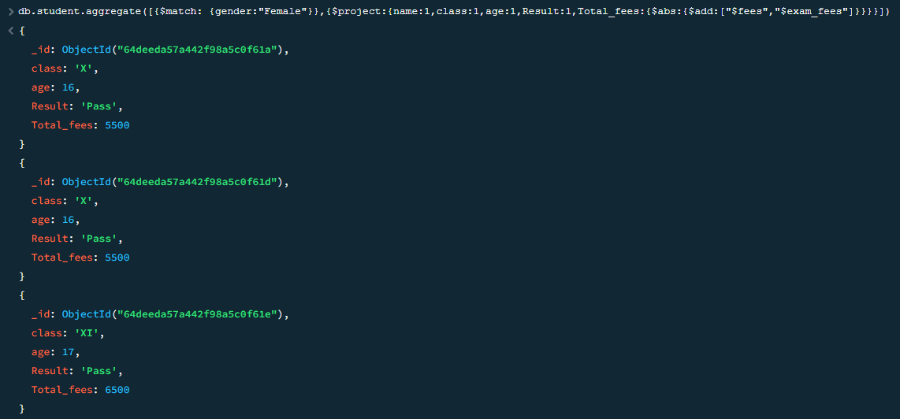

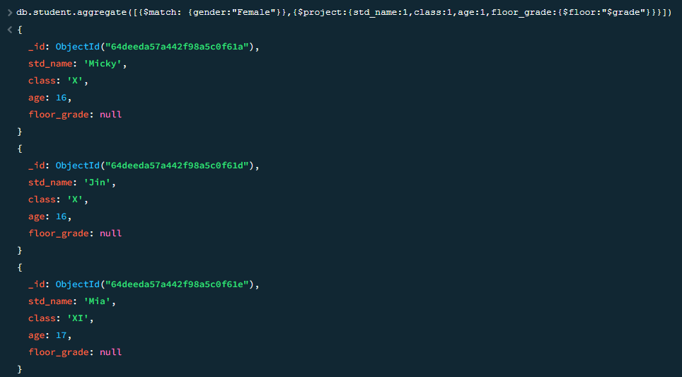

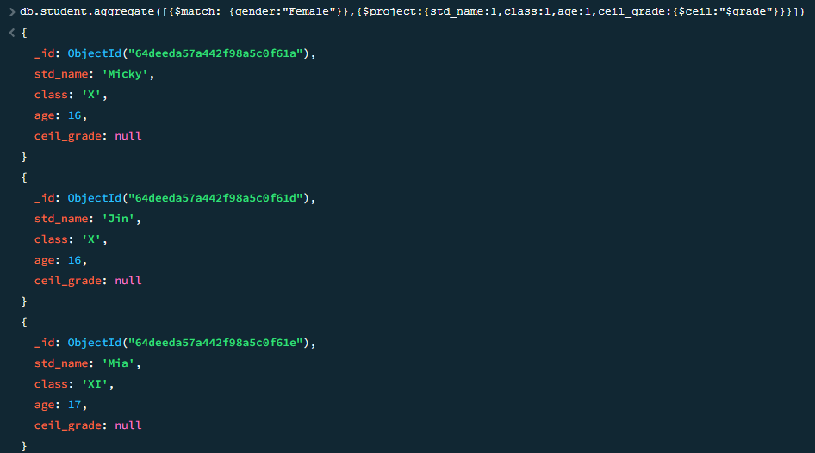

# **Practical 10: MongoDB $log, $mod, $divide, $multiply Operator**

1. Database: userdb
2. Collection: shapes
3. Document: Six documents that contain the details of the shapes

>db.example1.find().pretty()

{

{

"_id" : ObjectId("56254d4fdf2222265r4g1hb78452"),

"name" : "rectangle",

"area" : 16

}

{

"_id" : ObjectId("56254d4fdf2222265r4g1hb71478"),

"name" : "rectangle",

"area" : 6

}

{

"_id" : ObjectId("56254d4fdf2222265r4g1789654"),

"name" : "circle",

"area" : 19,

"unit" : {

"diameter" : 6,

"radius" : 3

}

}

{

"_id" : ObjectId("56254d4fdf2222265r4g1987412"),

"name" : "rectangle",

"area" : 20

}

{

"_id" : ObjectId("56254d4fdf2222265r4g1987412"),

"name" : "square",

"area" : 20

}

{

"_id" : ObjectId("56254d4fdf2222265r4g1987f15"),

"name" : "triangle",

"area" : null

}

}

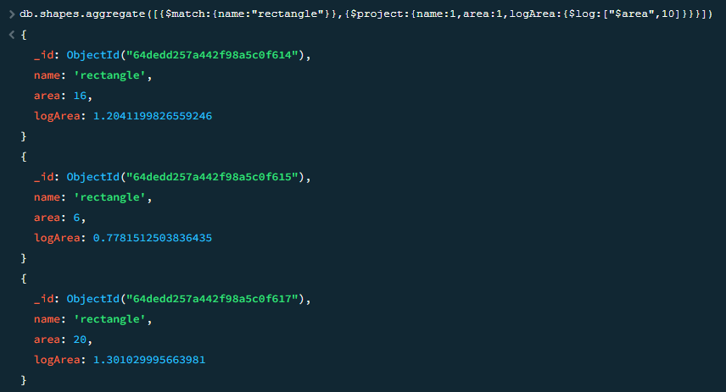

# **MongoDB $mod Operator**

1. Database: userdb
2. Collection: items
3. Document: Ten documents that contain the details of the items

>db.items.find().pretty()

{

{

"_id" : 1,

"item_name" : "Apple",

"total_Price" : null,

"quantity" : 40,

}

{

"_id" : 2,

"item_name" : "Banana",

"total_Price" : 1000,

"quantity" : 72,

}

{

"_id" : 3,

"item_name" : "Cherry",

"total_Price" : 215,

"quantity" : 25,

}

{

"_id" : 4,

"item_name" : "Apple",

"total_Price" : null,

"quantity" : 25,

}

{

"_id" : 5,

"item_name" : "Banana",

"total_Price" : 400,

"quantity" : 35,

}

{

"_id" : 6,

"item_name" : "Banana",

"total_Price" : 510,

"quantity" : 100,

}

{

"_id" : 7,

"item_name" : "Cherry",

"total_Price" : 500,

"quantity" : 41,

}

{

"_id" : 8,

"item_name" : "Rasbhari",

"total_Price" : 80,

"quantity" : "Ten",

}

{

"_id" : 9,

"item_name" : "Banana",

"total_Price" : 205,

"quantity" : 10,

}

{

"_id" : 10,

"item_name" : "Apple",

"total_Price" : 95,

"quantity" : null,

}

}

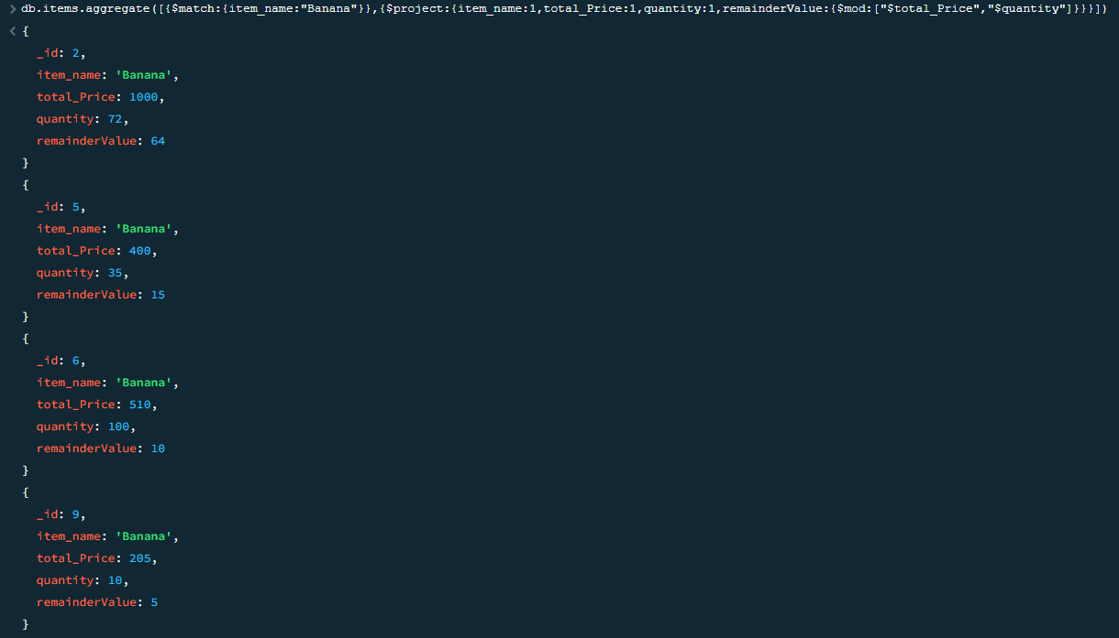

# **MongoDB $divide Operator**

1. Database: userdb
2. Collection: products
3. Document: Ten documents that contain the details of each product

>db.products.find().pretty()

{

{

"_id" : 1,

"name" : "Mobile",

"totalPrice" : 100000,

"totalQuantity" : 50,

"billYear" : 2018

}

{

"_id" : 2,

"name" : "Keyboard",

"totalPrice" : 5000,

"totalQuantity" : 10,

"billYear" : 2017

}

{

"_id" : 3,

"name" : "Mouse",

"totalPrice" : 2000,

"totalQuantity" : 5,

"billYear" : 2018

}

{

"_id" : 4,

"name" : "Memory Card",

"totalPrice" : 2500,

"totalQuantity" : 25,

"billYear" : 2019

}

{

"_id" : 5,

"name" : "Mobile",

"totalPrice" : 20000,

"totalQuantity" : 4,

"billYear" : 2020

}

{

"_id" : 6,

"name" : "Mobile",

"totalPrice" : 25000,

"totalQuantity" : 2,

"billYear" : 2021

}

{

"_id" : 7,

"name" : "Memory Card",

"totalPrice" : 1000,

"totalQuantity" : 10,

"billYear" : 2019

}

{

"_id" : 8,

"name" : "Pen drive",

"totalPrice" : 15000,

"totalQuantity" : "Two",

"billYear" : 2018

}

{

"_id" : 9,

"name" : "Laptop",

"billDetail" : {

"totalPrice" : 45000,

"totalQuantity" : 1,

}

"billYear" : 2021

}

{

"_id" : 10,

"name" : "Memory Carde",

"totalPrice" : 4000,

"totalQuantity" : 50,

"billYear" : 2020

}

}

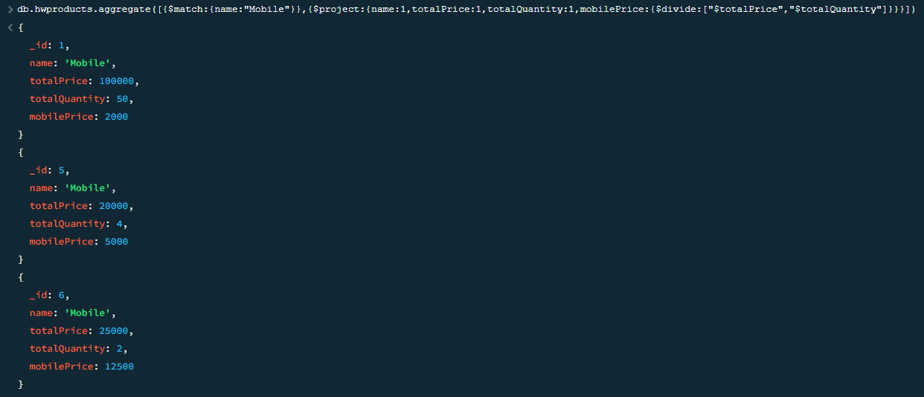

# **MongoDB $multiply Operator**

1. Database: userdb
2. Collection: products
3. Document: Ten documents that contain the details of each product

>db.products.find().pretty()

{

{

"_id" : 1,

"name" : "BlueBox",

"x" : 10,

"y" : 50,

"billYear" : 2018

}

{

"_id" : 2,

"name" : "GreenBox",

"x" : 10,

"y" : 6,

"billYear" : 2017

}

{

"_id" : 3,

"name" : "RedBox",

"x" : 7,

"y" : 9,

"billYear" : 2018

}

{

"_id" : 4,

"name" : "WhiteBox",

"x" : 2,

"y" : 7,

"z" : 4,

"billYear" : 2019

}

{

"_id" : 5,

"name" : "BlueBox",

"x" : 4,

"y" : 12,

"billYear" : 2020

}

{

"_id" : 6,

"name" : "BlueBox",

"x" : 10,

"y" : 5,

"billYear" : 2021

}

{

"_id" : 7,

"name" : "WhiteBox",

"x" : 5,

"y" : 1,

"z" : 45,

"billYear" : 2019

}

{

"_id" : 8,

"name" : "GreenBox",

"x" : -15,

"y" : 5,

"billYear" : 2018

}

{

"_id" : 9,

"name" : "BlackBox",

"billDetail" : {

"x" : 45,

"y" : 56,

}

"billYear" : 2021

}

{

"_id" : 10,

"name" : "WhiteBox",

"x" : 4,

"y" : 5,

"z" : 6,

"billYear" : 2020

}

}

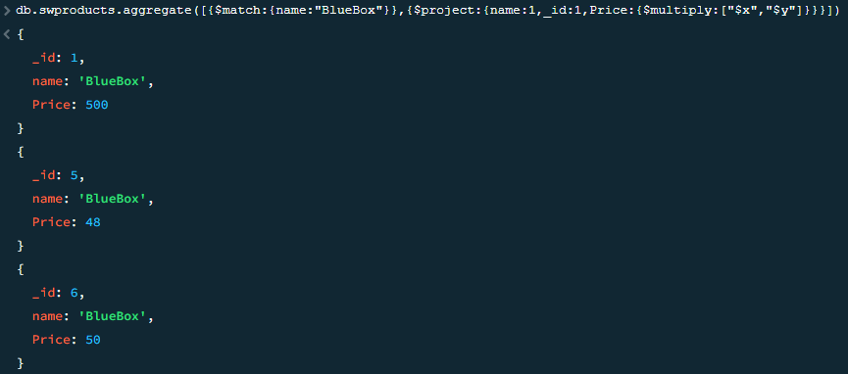

# **Practical 11: MongoDB $pow, $sqrt, $subtract Operator**

1. Database: userdb
2. Collection: shapes
3. Document: Six documents that contain the details of the shapes

>db.shapes.find().pretty()

{

{

"_id" : 1,

"name" : "rectangle",

"area" : 16

}

{

"_id" : 2,

"name" : "square",

"area" : 10

}

{

"_id" : 3,

"name" : "circle",

"perimeter" : 15,

"area" : 10,

"details" : {

"radius" : 3,

"diameter" : 6

}

}

{

"_id" : 4,

"name" : "rectangle",

"area" : 0

}

{

"_id" : 5,

"name" : "oval",

"area" : 20

}

{

"_id" : 6,

"name" : "triangle",

"area" : 5

}

{

"_id" : 7,

"name" : "rectangle",

"area" : null

}

}

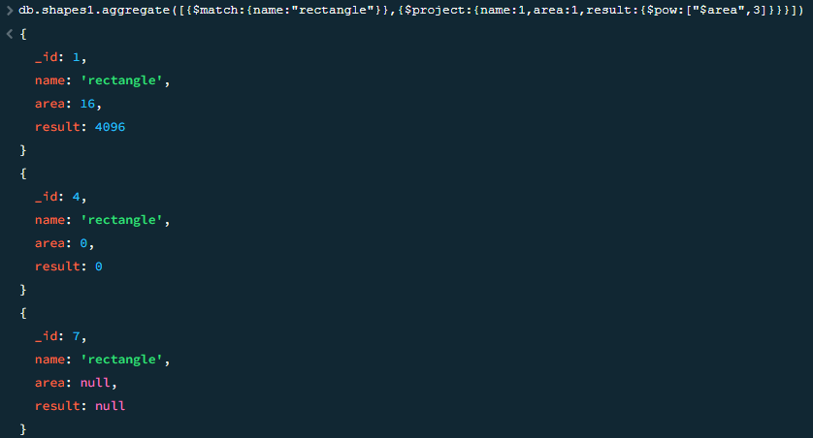

# **MongoDB $sqrt Operator**

db.items.find().pretty()

{

{

"_id" : 1,

"item_name" : "bat",

"quantity" : 4

}

{

"_id" : 2,

"item_name" : "ball",

"quantity" : null

}

{

"_id" : 3,

"item_name" : "box",

"details" : {

"length" : 20,

"width" : 25

}

}

{

"_id" : 4,

"item_name" : "ball",

"quantity" : null

}

{

"_id" : 5,

"item_name" : "bat",

"quantity" : 20

}

{

"_id" : 6,

"item_name" : "toy",

"quantity" : -10

}

{

"_id" : 7,

"item_name" : "bat",

"quantity" : 75

}

{

"_id" : 8,

"item_name" : "bat",

"quantity" : 45

}

}

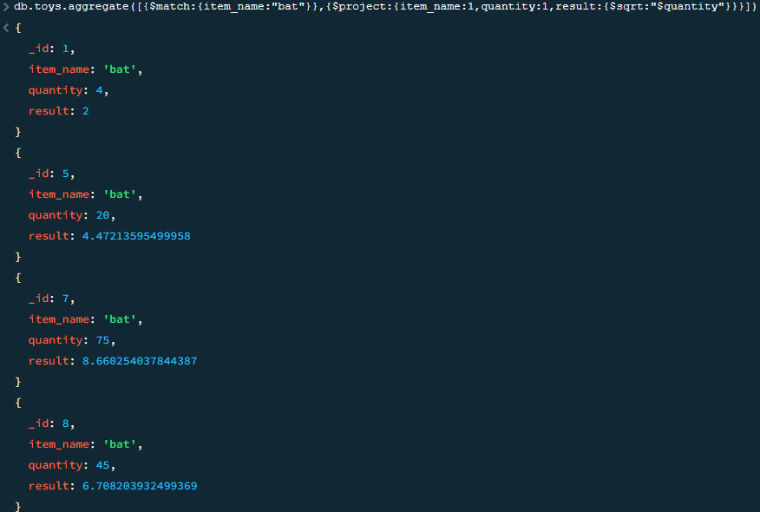

# **MongoDB $subtract Operator**

db.students.find().pretty()

{

{

"_id" : 1,

"std_name" : "John",

"father_name" : "Mick",

"department" : "MCA",

"semester_fee" : 6000,

"annual_fee" : 10000,

"start_date" : ISODate("2019-07-03T08:00:00Z"),

"end_date" : ISODate("2021-05-26T09:00:00Z")

}

{

"_id" : 2,

"std_name" : "Oliver",

"father_name" : "Thomas",

"department" : "BCA",

"semester_fee" : 4000,

"annual_fee" : 6000,

"start_date" : ISODate("2020-07-03T08:00:00Z"),

"end_date" : ISODate("2023-05-01T09:00:00Z")

}

{

"_id" : 3,

"std_name" : "Jack",

"father_name" : "James",

"department" : "MCA",

"semester_fee" : 7000,

"annual_fee" : 12500,

"start_date" : ISODate("2020-07-11T00:00:00Z"),

"end_date" : ISODate("2022-05-25T09:00:00Z")

}

{

"_id" : 4,

"std_name" : "Robert",

"father_name" : "David",

"department" : "Btech",

"fees" : {

"semester_fee" : 15000,

"annual_fee" : 22500

}

"start_date" : ISODate("2018-07-11T08:00:00Z"),

"end_date" : ISODate("2022-05-25T09:00:00Z")

}

{

"_id" : 5,

"std_name" : "Richard",

"father_name" : "William",

"department" : "BCA",

"semester_fee" : 11500,

"annual_fee" : 20000,

"start_date" : ISODate("2020-07-03T08:00:00Z"),

"end_date" : ISODate("2023-05-01T09:00:00Z")

}

{

"_id" : 6,

"std_name" : "Daniel",

"father_name" : "Paul",

"department" : "MCA",

"semester_fees" : 12500,

"annual_fee" : 25000,

"start_date" : ISODate("2018-07-11T08:00:00Z"),

"end_date" : ISODate("2020-05-25T09:00:00Z")

}

}

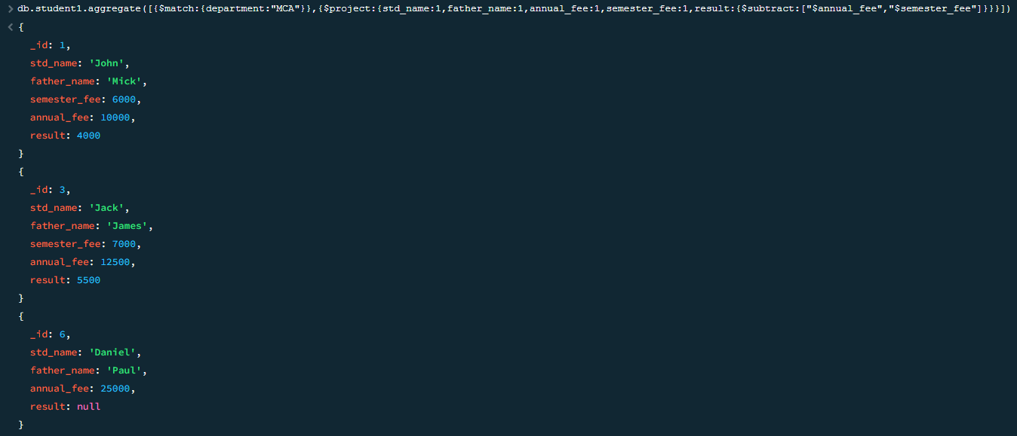

# **Practical 13: MongoDB $trunc, $round, $cmp Operator**

{

{

"_id" : 1,

"name" : "pen",

"data" : 11.25

}

{

"_id" : 2,

"name" : "pencil",

"data" : 10.32

}

{

"_id" : 3,

"name" : "box",

"data" : 15.97

}

{

"_id" : 4,

"name" : "bottle",

"data" : -12.3

}

{

"_id" : 5,

"name" : "oval",

"data" : 20.6

}

{

"_id" : 6,

"name" : "triangle",

"data" : 5

}

{

"_id" : 7,

"name" : "bottle",

"data" : -1

}

}

# **Practical 14: MongoDB $concat, $size, $rename Operator**

{

{

"_id" : 1,

"name" : "Steve",

"surname" : "Smith",

"department" : "B-tech",

"fees" : 80000

}

{

"_id" : 2,

"name" : "Sandy",

"surname" : "Beach",

"department" : "BCA",

"fees" : 55000

}

{

"_id" : 3,

"name" : "John",

"surname" : "Cena",

"department" : "MCA",

"fees" : 85000

}

{

"_id" : 4,

"name" : "Wick",

"surname" : "John",

"department" : "B.com",

"fees" : 60000

}

{

"_id" : 5,

"name" : "David",

"surname" : "Silva",

"department" : "null",

"fees" : 80000

}

}

# **MongoDB $size Operator**

{

"_id" : 1,

"name" : "Jonny",

"class" : "X",

"rollNo" : 401,

"age" : 18,

"marks" : [ 55, 60, 70, 45, 95, 68 ],

"extraMarks" : {

"practical" : [ 21, 18, 25, 30 ],

"attendance" : [ 5, 9 ]

}

"gender" : "Male",

"bloodgroup" : "A+"

}

{

"_id" : 2,

"name" : "Carry",

"class" : "IX",

"rollNo" : 35,

"age" : 17,

"marks" : [ 85, 40, 90, 75, 85, 77 ],

"gender" : "Male",

"bloodgroup" : "B+"

}

{

"_id" : 3,

"name" : "Jin",

"class" : "IX",

"rollNo" : 49,

"age" : 17,

"marks" : [ 85, 70, 80, 95, 94, 81 ],

"gender" : "Female",

"bloodgroup" : "O+"

}

{

"_id" : 4,

"name" : "Thomas",

"class" : "X",

"rollNo" : 61,

"age" : 18,

"marks" : [ 91, 65, 71, 63, 98, 76 ],

"extraMarks" : {

"practical" : [ 26, 28, 25, 29 ],

"attendance" : [ 8, 8 ]

}

"gender" : "Male",

"bloodgroup" : "A+"

}

{

"_id" : 5,

"name" : "Mia",

"class" : "IX",

"rollNo" : 308,

"age" : 17,

"marks" : [ 97, 98, 95, 98 ],

"gender" : "Female",

"bloodgroup" : "B+"

}

{

"_id" : 6,

"name" : "Oats",

"class" : "IX",

"rollNo" : 75,

"age" : 18,

"marks" : [ 99, 98, 98, 95, 96 ],

"gender" : "Male",

"bloodgroup" : "A+"

}